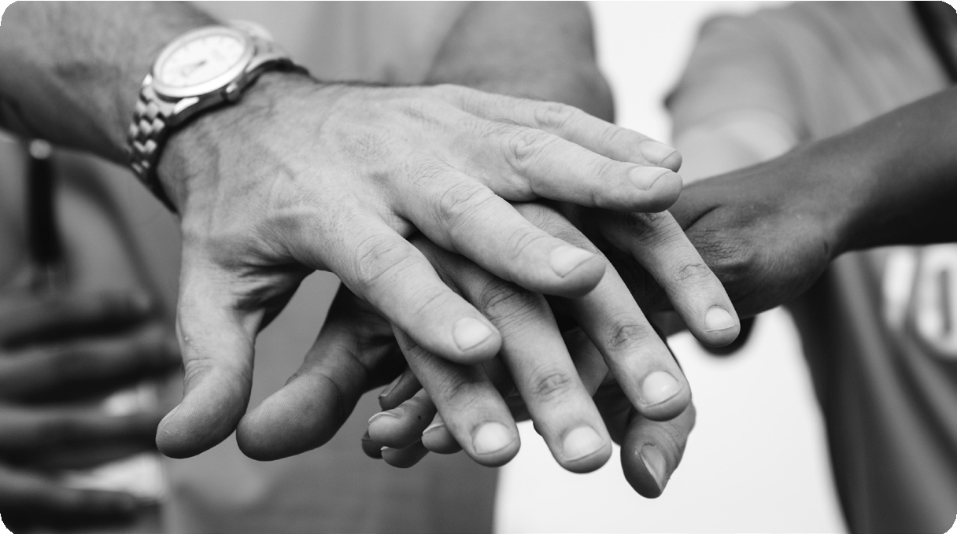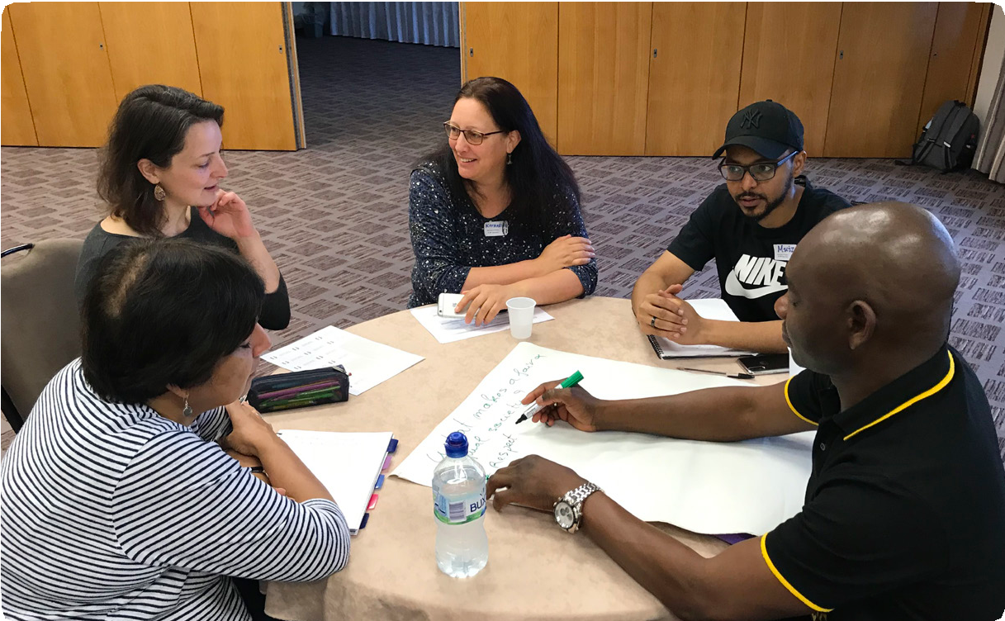

Talk.Act.Change.

Use Your Rights
to Make
Your Voice Heard

Conversation Toolkit

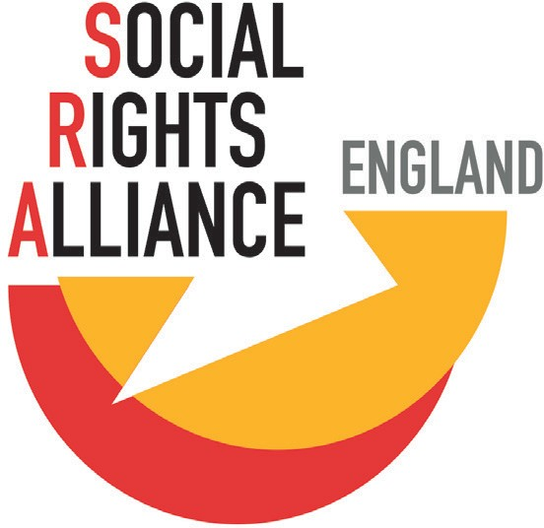

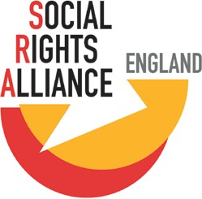
socialrightsalliance.org.uk
@SRA_England

This toolkit is designed to get people talking across England about social rights and the change we’d like to see. By the end of this conversation, you will have a better understanding of the day-to-day rights that we all have and how you can encourage change in your local area.

Why?

People all over the world are having conversations like this. Real and effective solutions must come from the community.

Travellers in Cork are demanding water, sanitation, infrastructure and housing solutions that are rooted in the community and respond to the needs and preferences of its members. Social housing tenants in Belfast and Edinburgh are monitoring how well local authorities are satisfying their human right to adequate housing. People across Scotland are working together to champion food justice in Scottish law and policy. There are other inspiring examples of community-led monitoring of human rights from Buenos Aires to Nairobi and Delhi.

All these initiatives have something important in common. They are putting human rights into day-to-day conversation, making international human rights law locally relevant. Communities around the world show that human rights are much more than a shield to protect the individual from the state. Human rights also have a unique ability to help people move and work together for change.

Contents
Conversation Guide Suggested session plan Important Info Response Sheet
Want to read more?
4
6
8
10
12

Conversation Guide
Holding a conversation

You can be as creative as you like in holding this conversation. If you want some help, there is a workshop format suggested on page 10-11. You could also look at other facilitation techniques if you would like to try something different.

The ‘Response Sheet’ is left blank for you to fill in as you discuss the questions. Try to be as specific as you can, especially when writing down your issues and ideas for change. For example, instead of writing ‘Improve public transport’, tell us which bus service you want restored or protected, or how much you’d be willing/able to pay for public transport in your area.

This toolkit can be used by anyone! You could invite some of your friends or colleagues to get together in your own home, at work, in a café – anywhere! The important thing is that everyone feels able to take part and have their voice heard.

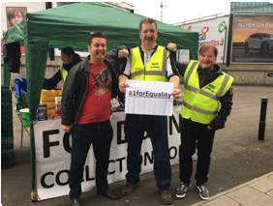
The ‘Important Info’ sheet
The ‘Important Info’ sheet explains what human rights are and how they affect you. It can help get a conversation going when you don’t know how to start answering one of the questions in the ‘conversation sheet’. It also has links to websites for further information if you want to read more.
8
What are ‘social rights’?
Human rights are the basic rights and freedoms that every person in the world has from birth to death, simply because they are a human being. Human rights are laid out in international law, the most well-known document being the Universal Declaration of Human Rights. This was written in 1948 and has 30 articles.

Social Rights are the essential conditions needed to live a life of equality, dignity and freedom. They include the right to work and workers’ rights, social security and social protection, health, education, food, water, housing and an adequate standard of living. They are day-to-day rights that affect us from when we wake up in the morning to when (even where) we go to sleep at night.
This information explains what human rights are and how they affect
you. It can help get a conversation going when you don’t know how to start answering one of the questions in the ‘response sheet’.

What is ‘equality’?
When people are treated equally they have access to the same opportunities, experiences and respect no matter whether they are a man or a woman, young or old, a refugee or not. The colour of someone’s skin, their sexuality or disability should not stop them from getting secure jobs, having a good education or being able to access benefits.

Equality is also about material resources . The widening gap between the rich and the poor; a national minimum wage that doesn’t cover basic living costs; a tax system that rewards the rich; a benefits system that brings people into poverty. These are all equality issues.
Important Info
Talk.Act.Change.

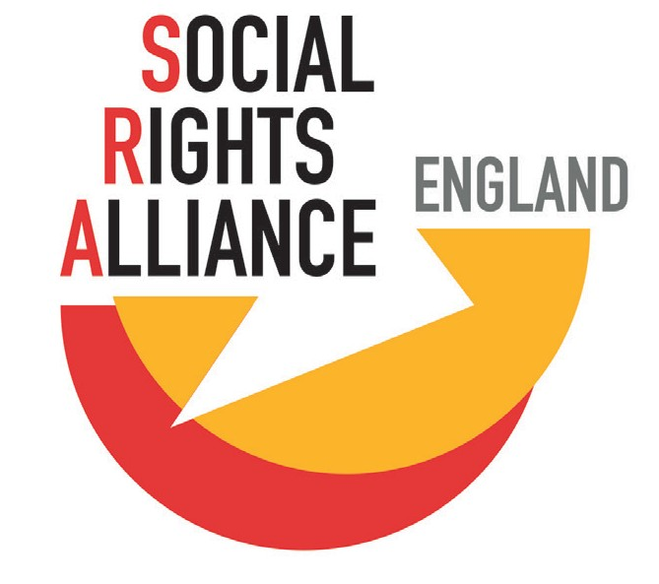
SHARE

@SRA_England
What to do once you’ve finished all the talking

We are collecting the responses to these questions from across England to build a picture of people’s main concerns and ideas for change. To help us with this please send a photo, scan or email of your responses to the questions to sra@justfair.org.uk. Or you can drop it back at the place you picked up the toolkit from.

Your responses are part of a wider conversation across the country about how to improve access to our social rights. The Social Rights Alliance England (SRA) will look for common issues or concerns raised. This will help us to develop campaigns for local and national change, and work to reduce inequalities in England.

But the conversation does not need to end here! If you want to talk more about your ideas or get involved in action then get in touch with sra@justfair.org.uk.

Share, share, share!
We’d love it if you shared this toolkit with others, so we can get even more responses! You can also follow us on social media.

@SRA_England
socialrightsalliance.org.uk

If you want a little help...

...here’s a 2-hour session plan:

Vision for Society 15 mins

Working in pairs or small groups, explore what you think makes a fair and equal society. Write your ideas down on large sheets of paper or use the Conversation Sheet. After
5 minutes, stop and read the ‘What is equality?’ section of the Info sheet. How does this compare to what you wrote before? Spend another 3-5 minutes adding down new thoughts. Each pair or small group feedback two main things that contribute to a fair and equal society.

Know Your Rights 15 mins

Read through the section about social rights from the Info Section. Discuss why social rights are important to you.

Reality Check 15 mins

Compare the vision for an equal and fair society with where you live. Do they look the same? If not, why? Does anything stop people in your area from feeling equal? Be as specific as you can here.

Break 10 mins

Now might be a good time to have a short break. This can help to keep minds fresh and ideas flowing! Get up and move around, make a cuppa, go outside… whatever will help to boost your energy.

Top 5 Concerns 20 minutes

In smaller groups, spend 15 minutes talking about the issues in your area that really bother you. For example, ‘Older people are isolated because transport links in are poor’, or ‘There aren’t enough secure jobs in our area – there are too many zero-hours contracts’. Write these down onto post-it notes or small pieces of paper. Write each issue on a separate piece of paper.

Now, take 5 minutes to organise the issues to see if any other groups said the same things.

Final thoughts 5 minutes

Tie up the session by sharing what you are taking away from it
– What have you learnt or what is your next step? Take a photo or scan of what you have written down or suggested and send to sra@justfair.org.uk.
Ideas/Solutions 30 mins

Now is the opportunity for you to think about how you would like things to be different. Using a technique called 1-2-4-All, ask the group ‘What would you like to be different? What is the change you want to see? If you were going to ask your local council to do something about the issues you have raised, what would you ask them to do?’

Start off by thinking about these questions on your own silent for 1-2 minutes. Next, discuss your thoughts and ideas in pairs for 5 minutes. Now develop these ideas further in groups of four for 5 minutes. Again, be as specific as you can. For example, ‘To bring back the bus service between
… and … to reduce social isolation’, or ‘To become a real living wage employer (including all their care staff)’.

Finally, each group shares back their main ideas to the whole group. Take no more than 5 minutes for the feedback.

What can you do? 10 minutes

‘Even a 100-mile journey starts with a single step’. Take this time to identify the steps or actions that you can take to contribute to the change they want to see. Think about what you could do now. It could be as simple as ‘Share this toolkit with my friends or colleagues’, or ‘Write to my councillor or MP about the issues we have talked about’.
Each person can reflect on this on their own for 1 minute then share their ideas in pairs or small groups for 5 minutes.

Talk.Act.Change.

Important Info

This information explains what human rights are and how they affect you. It can help get a conversation going when you don’t know how to start answering one of the questions in the ‘response sheet’.

What is ‘equality’?
When people are treated equally they have access to the same opportunities, experiences and respect no matter whether they are a man or a woman, young or old, a refugee or not. The colour of someone’s skin, their sexuality or disability should not stop them from getting secure jobs, having a good education or being able to access benefits.

Equality is also about material resources . The widening gap between the rich and the poor; a national minimum wage that doesn’t cover basic living costs; a tax system that rewards the rich; a benefits system that brings people into poverty. These are all equality issues.
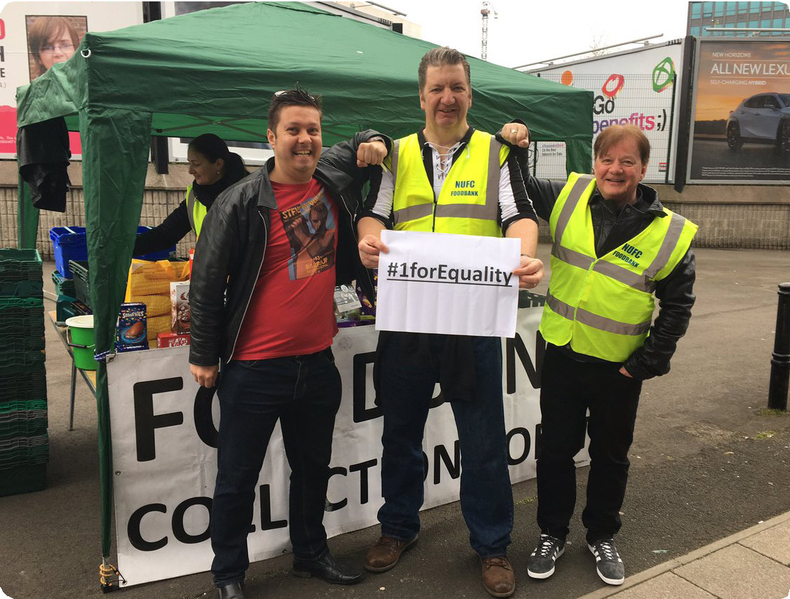
What are ‘social rights’?
Human rights are the basic rights and freedoms that every person in the world has from birth to death, simply because they are a human being. Human rights are laid out in international law, the most well-known document being the Universal Declaration of Human Rights. This was written in 1948 and has 30 articles.

Social Rights are the essential conditions needed to live a life of equality, dignity and freedom. They include the right to work and workers’ rights, social security and social protection, health, education, food, water, housing and an adequate standard of living. They are day-to-day rights that affect us from when we wake up in the morning to when (even where) we go to sleep at night.

The UK has recognised the importance of human rights by signing up various international documents, including the International Covenant on Economic, Social and Cultural Rights (ICESCR). Among other things, this document says that governments have a responsibility to make sure that:
Example 2: Naysan needs to go to a hospital appointment for a chronic health condition. It used to be easier to get to the hospital, but since a private company took over the buses they have reduced bus routes and buses, and have raised the cost of travel. It now takes him almost 2 hours using 2 buses. As Naysan works on a zero-hours contract, he had to give up a shift in order to attend his appointment.
The first bus is delayed, so Naysan misses the second and therefore arrives late for his appointment. The hospital won’t see him, and the next available appointment is in 4 weeks. He ends up having to take time off work due to poor health as a result of missing the appointment. Naysan’s right to healthcare, work and worker’s rights have been affected.

- Everyone has equal access to their rights regardless of their background, gender, nationality etc.
- They are always trying to improve policies relating to social rights.
- If the government takes a step backwards due to an economic crisis, for example, the measures must be temporary and reasonable, and disadvantaged groups must always be protected.

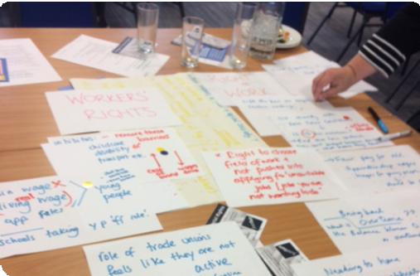Social rights are as important in international law as other human rights , like freedom of expression or the right to a fair trial.
How does this affect me?
These rights are all linked. If one is affected, others will suffer too.
Example 1: Julia has been waiting for her universal credit payment for too long and has no other income . She is unable to pay her rent, which has frustrated her landlord. In order to heat her home and feed her children, Julia has chosen not to feed herself. This is affecting her performance at work as she is tired and cannot concentrate. Julia’s right to social security, food, housing, health and work have all been affected.

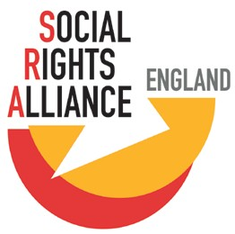socialrightsalliance.org.uk
@SRA_England

Talk.Act.Change.
Conversation Toolkit

What makes an equal and fair society?

Think of where you live. Does it look like this?

Why are your social rights important to you?

10

What could you do to help bring the change you want to see?
What are your top 5 concerns?
1 ..................................................................................
2 ..................................................................................
3 ..................................................................................
4 ..................................................................................
5 ..................................................................................
What are your solutions to these concerns?

Please send a photo, scan or email of your responses to sra@justfair.org.uk
Or drop this form off at
the place you collected it from

Get involved in your local Social Rights Alliance:
www.socialrightsalliance.org.uk/ regional-alliances

Follow us on Twitter
@SRA_England

Want to read more?
Social Rights Alliance England: www.socialrightsalliance.org.uk

Universal Declaration of Human Rights:
www.un.org/en/universal-declaration-human-rights/

More about social rights: www.socialrightsalliance.org.uk/your-rights

Creative facilitation techniques: https://www.sessionlab.com/

PPR Belfast (groups of residents using human rights for local change): https://www.pprproject.org/

My Rights Passport, Amnesty International (simple explanations of the Universal Declaration of Human Rights, ideal for use in schools) https://www.amnesty.org.uk/resources/my-rights-passport

Get involved with Social Rights Alliance England:
Everyone has the right to good education, adequate housing, public healthcare, equality, food, strong social security and a decent standard of living. This is what makes a free and fair society.

Social Rights Alliance England is working to improve access to these rights for all people. Anyone can get involved and every voice is valued.

Visit our website: www.socialrightsalliance.org.uk

Or get in touch with us by emailing: sra@justfair.org.uk

