Talk.Act.Change.
How and why to contact your local politicians to tackle
issues in your community

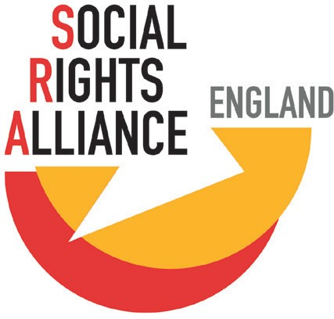
www.socialrightsalliance.org.uk

@SRA_England

Contents
2 About this guide
4 MPs
- Councillors
- Local authorities
- Next steps
- Tips and tricks
- Example letter
- Useful campaign tools
- Other handy resources

About this guide

Who?

This guide is for people in England who would like more confidence in speaking with their local politicians, and those who want to learn more about how politicians can support them. It is full of information and tips on when and why you could contact your local politicians.

Icons on pages 5, 6 and 9 were created by Muhammad Rafli and used under Creative Commons (Attribution 3.0 Unported). The colour of the first icon on page 9 has been edited.

2

Why?
As a human being, you have the right to have your views heard and to take part in the democracy we live in. You elect local politicians, like MPs and councillors to represent you and your community. It is their job to listen to you and represent your views in local and national government.

Too often people are not included in decision-making that affects them. The ‘Digital by Default’ aspect of the benefits system is a good example of this. Many people struggle or are unable to apply for benefits online. If those making the decisions had a better understanding of this, then the benefits system could work better for more people. Talking to your local politicians will help them better understand your perspective and experience and help you to have an influence over laws and policies. This will mean that new laws and systems will better suit you and reflect your community’s needs.

It can be nerve-wracking contacting your local councillor or MP, especially if you haven’t done it before. Understanding how and why they could help will give you more confidence to get in touch, and feel more in control of problems affecting you.

This guide tells you:
- How to contact your local politicians
- What they can help you with
- Where you can find some extra help

There is also an example letter to a councillor to give you an idea of what you
might need to include.

3

MPs

What do MPs do?

MPs (Members of Parliament) are voted for in general elections to represent people in their area. It doesn’t matter whether you voted for your MP or not - they are there to support you and represent your views in the UK’s Parliament. The UK Parliament is where politicians make laws and UK wide policies.

MPs split their time between working in the UK Parliament and working in their local area. In Parliament, MPs promote the interests of the people they represent, and attend debates and meetings. They vote on changes to laws and ask the UK Government ministers questions about current issues.

All MPs hold advice ‘surgeries’ in their area for residents. These are for people to tell them about local issues and problems they may be facing. MP’s can then take these issues up with UK Government departments and the local council.

MPs spend some of their time attending meetings and community events. They visit local organisations and businesses, to get a better sense of what is happening where they live.

4

What can I discuss with my MP?

MPs can offer support on different issues, but are most likely to be able to help with UK Government services including:

- Benefits, child support and pensions
- Tax
- The NHS
- Immigration

MPs can have specialist roles. Some may have responsibility for a specific area of policy, such as transport or housing. If you contact your MP for something they can’t help with, they should direct you to the right person.

How can I get in touch with my MP?

Each member of Parliament has their own website which will have their contact details. If you’re not sure who your MP is you can find out by putting your postcode in here: www.parliament.uk/findyourmp
Most MPs will also use some form of social media.

If you don’t have access to the internet, you can find out who your MP is by going to your local civic centre or county hall. Alternatively, you can call the House of Commons Information Office on 0800 112 4272 or 020 7219 4272.

5

Councillors

What is a councillor?

Councillors represent residents in a smaller local area, known as a ward. They are elected to serve on the council in local elections. They are normally the first point of contact for people when they have a local issue, or an issue with the council.

Councillors are based within a community but unlike MP’s do not get paid a salary for this work, so they often have other jobs. It is important to know that councillors do receive a ‘member’s allowance’ for their time and/or are paid expenses. How much they receive is decided by each individual council.

What do they do?

Councillors spend their time:

- Supporting people who live in their area (or ward) and making sure the council’s plans take their needs into account.
- Holding monthly advice ‘surgeries’ in their local community and talking to residents and community groups about issues or challenges they want to raise.
- Working on council committees to make sure the council is doing its best in areas such as equality, climate change and housing.
- Deciding on and finalising the council’s budget. This outlines how much the council will spend on different services.

How can I get in touch with my local councillors?
One of the best ways to speak with your councillor is in one of their regular ‘surgeries’.

Each council will have a list of councillors on their website. You can also put your postcode into this website, and it will take you to them:

www.gov.uk/find-your-local-councillors/
Most councillors will also use some form of social media.

If you don’t have access to the internet, you can find out who your councillor is by going to your local civic centre or county hall. Or you could ask a neighbour – they might know too!

6

Local authorities

What are local authorities?

Every area has at least one form of local authority, usually a county, borough, or city council. Local authorities provide many essential services like social care, libraries and waste collection. They also cover aspects of housing, transport and education. Local authorities try to look after the interests of their communities through their councillors (see page 6).

Every local authority creates a ‘budget’ each year. This outlines how much they will spend on different services. UK Government grants, council tax, and car parking charges are examples of how local authorities source their money.

Parish, community and town councils
Many places also have a parish or town council to look after a smaller population of people. Although they have fewer responsibilities, they play a crucial role in representing the concerns of local people and have the ability to influence decisions made at the county, city or regional level.

Which council area do I live in?

You can find out which local authority area you live in by putting your postcode into this website: https://www.gov.uk/find-local-council. Their website will be shown once you have done this and their contact details can be found on their websites.
Most local authorities will also be found on social media.

The best way to find out who your local authority is if you don’t have the internet is by asking your neighbours. Or you could look at who you pay your council tax to!

7

Local authorities
8

Combined authorities

Some local authorities work together to share some of their powers, finances and responsibilities. Known as a ‘Combined Authority’, these organisations are led by councillors from each individual council involved. All Combined Authorities have an elected mayor
to make sure they meet their responsibilities. You can find out if you live in a Combined Authority area here: www.local.gov.uk/topics/devolution/devolution-online-hub/ devolution-explained/combined-authorities. They have an elected mayor to make sure they meet their responsibilities.

Generally, combined authorities have a special agreement with the UK Government. This gives them extra finances and more decision-making powers to use at a local level.
Arrangements can include extra powers over transport, adult education, and skills, but the exact deal is unique to each combined authority.

Next steps
What next?
If you have an issue or a problem that you think a councillor or MP could help with, the next step is to get in touch with them. Use the information given in this guide to find contact details for your politician. Now you just need to send them an email, a letter or try to speak with them. An example letter can be found towards the back of this guide to give you some ideas.

The next section gives you useful tips and tricks for when you contact your local politicians.

Tips & tricks

Be Prepared
Be Prepared
- Make sure you have thought through exactly what you want to say and what you would like a councillor or MP to help with.
- Find out if a councillor or MP focuses on a particular topic linked to your issue. Knowing their specific roles might help you to find someone who is more likely to support your issue or campaign.
- Do some research on the person you are approaching. It can help to know what political party they represent, and how they might have voted on similar issues in the past. This can give you an idea of how they might respond to your issue and how you might be able to encourage them to support you.
- Be aware of important political dates. Contacting your local politicians right before an election might mean it takes longer to hear back from them. But it might be a good opportunity to get their backing for the issue you are raising
– something that you can hold them to if they are elected!
Be Clear

- Make sure your ‘ask’ is clear, realistic, and supported by as much evidence as you think you might need.
- Identify the key points of your issue and what you are asking them to help with– make your points clear and punchy!
Be Clear

- It may sound simple but try not to get angry or shout. Try to remember that MPs and Councillors are there to listen to you. They are also just people!
- If you don’t receive a response from your politician after a while, it might be worth sending a follow up message, just in case the original got lost.
Be Calm

9

Example letter

Here’s an example of a letter to a councillor...

Dear Cllr [Surname]

My name is [Full Name], and I am writing to you because I am worried about the council’s plans to close our local youth centre.

The youth centre is a place for many young people in our community to meet with their friends and take part in various activities. Meeting in the centre means they can be safe, be supervised and get involved with other community events. The weekly youth group that runs there has also helped to reach out to young people in the community who were creating trouble and damaging property because they ‘had nothing to do’. Now, the community feels safer and those young people are able to express themselves more.

The centre is also a place for the community to run other activities like the support group for young mothers, English classes and the ‘Knit and natter’ group. The centre provides a secure space for these groups to meet. Without the centre, these groups would be forced to stop as there is nowhere else nearby that they can hire. Without the centre, our whole community suffers.

I understand that the Council is working hard to support people as best it can.
I would like to encourage the Council to reconsider its plans to close the youth centre. Keeping it open would allow young people and others to continue to enjoy the activities there and feel part of a community.

I would be grateful if you could raise this issue at the next full council meeting and explore ways to keep the centre open. I am happy to talk with you about this in more detail.

Kind regards,

[Name]
[Full Address]

10

Useful campaign tools

Here are some useful tools you could use to make your voice and issue heard. The first two are actions you could ask your councillor or MP to take up on your behalf. The last could be something your community group decides to respond to.

Council motion

A council motion shows a councillor’s, and your local authority’s support for an issue. But they do not typically lead to policy changes. Council motions can either be about the council or government policy.

Council motions need to be presented to the full council chamber by one councillor. They are then debated and all councillors vote on whether they want the motion to pass or not. If it passes, this is often the first step a council takes towards changing their policy.

Early Day Motions

Early day motions (EDMs) showcase an MP’s support for an issue and are submitted for debate in the UK’s House of Commons, part of the UK’s Parliament. They can also lead to further debate on the issue.

EDMs can attract a lot of public interest and media coverage so they can be helpful in promoting a campaign or issue more widely.
You can find existing EDMs here and see if your MP has signed it:
https://edm.parliament.uk/

Committees & inquiries

UK Government committees are made up of MPs or Lords. They consider policy issues, examine UK Government work and spending, and look at potential new laws. Committees will sometimes run an ‘inquiry’ into a specific issue which anyone can respond to if they feel the issue affects them.

You can find out about what committees exist and look for open inquiries here:
https://committees.parliament.uk/

11

Get involved with Social Rights Alliance England:
Everyone has the right to good education, adequate housing, public healthcare, equality, food, strong social security and a decent standard of living. This is what makes a free and fair society.

Social Rights Alliance England is working to improve access to these rights for all people. Anyone can get involved and every voice is valued.
Visit our website: www.socialrightsalliance.org.uk
Or get in touch with us by emailing: sra@justfair.org.uk
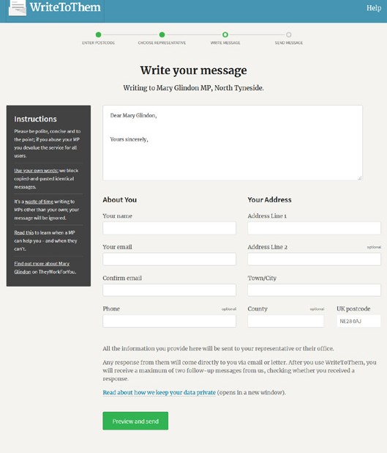Other handy resources

Write to them
You can email all of your representatives here
https://www.writetothem.com/

Talk.Act.Change toolkit
A guided conversation through identifying issues and formulating ‘asks’
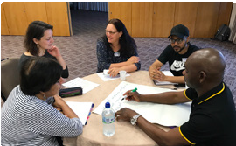https://www.socialrightsalliance.org.uk/campaign-resources

Talk.Act.Change.
Use Your Rights to Make
Your Voice Heard

Conversation Toolkit

Getting your voice heard
More information on how and when to contact your MP By The House of Commons.

Mobilisation laboratory
Useful resources and ideas for developing campaigns

https://mobilisationlab.org/

Lobbying your MP
The ‘Do’s’ and ‘Don’ts’ by Asylum Matters
https://asylummatters.org/resources/campaigning-resources/

Top tips for Influencing Decision Makers
By Asylum Matters

Planning Research for Influencing
By Oxfam

